Weekend Brunch

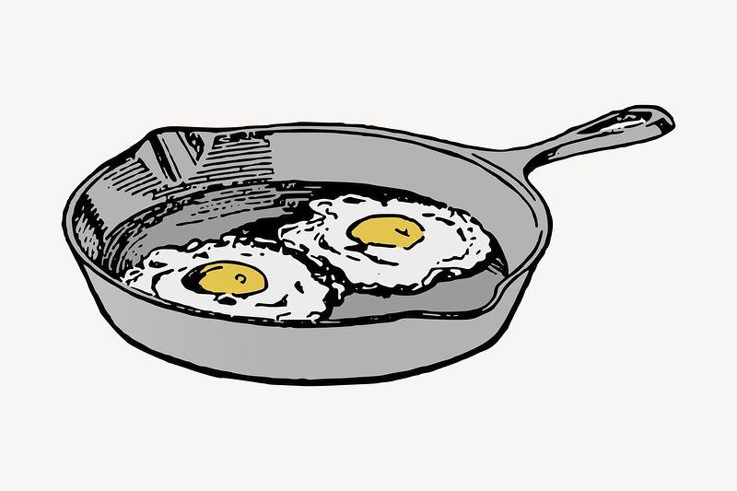 Served Saturday 11am-2pm and Sunday 10am-2pm

Mains
O.H Breakfast 2 eggs, pork sausage and bacon with home fries, maple baked beans with your choice of toast (white, whole wheat, brown toast) 17/ add biscuit 3/ sub gluten free toast 1.50/ add extra egg 2/

Sausage Biscuit with house made chicken sausage patty, fried egg, smoked cheddar and tomato jam on a homemade buttermilk biscuit with home fries 17/

Eggs Benedict – Choice of the Classic Eggs Benny with peameal bacon or the vegetarian version of Eggs Florentine with spinach 18/

Shakshuka is a classic North African and Middle Eastern breakfast dish of poached eggs in a simmering tomato sauce with spices, topped with feta cheese and served with pita bread and home fries 18/

Daily Omelette- 3 large eggs with home fries and choice of toast- white, whole wheat, rye, or gluten free add 1.50 /17/

Cheesy Eggs fluffy scrambled eggs and cheese on a fresh baked butter croissant with strip bacon, lettuce and tomato served with home fries 16/ no bacon 15/

PBLT peameal bacon, lettuce and tomato and mayo on choice of bread with frites 15/

Buttermilk Pancake w/ butter, real maple syrup 13/

Feature Pancake - always different always delicious 15/

Tofu scramble with vegan cheese, home fries, sliced tomato, and toast 16/

Other stuff…
Side Bacon or Sausage (4 pieces) 5/

Side Home fries – made in-house using Yukon Gold and Sweet Potatoes with onion 5/

Side Pancake 4/

Side Eggs (2) any style 4/

Lunch

After 12pm
O.H Burger 7 oz brisket, chuck and short rib patty on an Ace Bakery bun with lettuce, tomato, pickle and red onion with hand cut frites 18/
Add Bacon 2/ Smoked cheddar cheese 2/ Caramelised onion 2/

KFC Sandwich Korean fried chicken with kimchi, red onion, Korean aioli, lettuce, on an Ace Bakery bun and frites 18/

Classic Club Sandwich a triple decker with grilled chicken breast, crisp bacon, tomato, lettuce, roasted garlic and lemon aioli and frites 18/

The Cheesiest…Grilled Cheese made with a blend of three cheeses, melty and delicious served on choice of bread with frites- 12/ add tomato 1/ or bacon 2.00/

Greek Salad chopped romaine, peppers, red onion, kalamata olives, cucumber, tomatoes, with a housemade Greek feta dressing, topped with feta Small 9/ Large 18/

House Salad heritage greens, tomatoes, cucumbers, tomatoes and balsamic vinaigrette (Vegan)
Small 8/ Large 15/

Caesar Salad chopped romaine, parmesan, crouton, bacon, lemon with a house made caesar dressing
Small 9/ Large 18/ Add Chicken Breast, Shrimp or Crispy Tofu for 6/

BRUNCH BEVERAGES
MIMOSAS 9/
Fresh Orange Juice
Fresh Grapefruit

O.H Caesar 10/
Mild, Medium or Spicy

Fresh Squeezed Juice 7/ Orange or Grapefruit

Bottomless Organic Fair Trade Coffee 3.50/

Americano 4/ Latte 5/ Cappuccino 5/ Hot Chocolate 4/ Hot Apple Cider 4/

Kids - Apple Juice, Orange Juice, Cranberry Juice, Milk or Chocolate Milk 2/

Kids Brunch 12/

- Kid’s Pancake with fruit, syrup and bacon or sausage
- Kid’s Breakfast 2 Eggs, toast, potatoes with bacon or sausage
- Grilled Cheese with fries
- Homemade Chicken Strips with Plum Sauce, Carrot and Celery Sticks and Fries

Kid’s meals served with choice of small soft drink, juice, plain milk or chocolate milk
This meal is for children aged 12 and under only and not available to adults.

